Automatic Hand Sanitizer Container to Prevent the Spread of Corona Virus Disease

*Komala T*

*Department of Electronics and Communication Engineering*

*Anna University Regional Campus, Coimbatore, Tamilnadu, India*

*komalatamil1542@gmail.com*

*Jerusha Jaisal J L*

*Department of Electronics and Communication Engineering*

*Anna University Regional Campus, Coimbatore, Tamilnadu, India*

*jerushajaisal@gmail.com*

*Balaa Rupeni S*

*Department of Electronics and Communication Engineering*

*Anna University Regional Campus, Coimbatore, Tamilnadu, India*

*balaarupeni451@gmail.com*

**ABSTRACT**

Coronavirus pandemic has impacted human existence in different areas. Different endeavors were made to decrease the infection moving by telecommute, social separating, and furthermore including hand cleanliness. Up until this point, the greater part of the accessible hand sanitizers don't work consequently. This article means to make a programmed hand sanitizer where cleanser and water can come out naturally. Other than that, robotized hand sanitizer will make notice to the proprietor, assuming the fluid has headed out to the cell phone. The infrared (IR) will detect the presence of hotness and movement of the article with the distance up to 50mm. It send information to the Arduino Nano to actuate the siphon. In the event that the ultrasonic sensor distinguish the distance of water to the sensor 35 cm it will send information to hub MCU that interface with Squint server. It can move the information to the result gadgets, for example, cell phones or PC dependent on the Web of Things (IoT). The aftereffects of the hand sanitizer testing that the framework can run as expected with a base location blunder of moving information

***Keywords****— Automatic hand sanitizer, Infrared sensor, Ultrasonic sensor*

# INTRODUCTION

At the beginning of 2020, the virus spread rapidly in some countries. The first virus associated with it has been reported to Wuhan, Province of Hubei. [1] WHO has been appointed this 2019 new coronavirus (2019-ncov) disease, its name replaced by coronavirus disease (COVID-19) disease (COVID-19) (COVID-19) Acute Respiratory Syndrome Seriously Coronavirus- 2 (Sars-COV-2) [2]. This virus is at the national level (virus that begins with bats transmitted between animals and humans [3]. Then, this virus can also be sent from man to man [4]. Aerial coronavirus, direct or indirect contact. However, it is more widespread. The symptoms caused by this virus are the calm influenza, that is to say cold, pain, sore throat, cough, fever, breathing difficulties. In the case of Severa, Covid-19 can. It appears as pneumonia. The patient can grow acutely with short and dying breathing syndrome of multiple defamed organs [5].

The presence of this disease considerably affects society and the economy. Who declared this and is a lot

of pandemic disease and many cities around the world. Virus to prevent the cause, it can be done by keeping at least a distance, avoid going to a place filled with people, without touching, mouth, nose, cleaning soap or hand based on alcohol. Rub the hand of [6]. Spaces that provide containers for cleaning internal fluids are a COVID-19 prevention type, but the container provides a part that is currently invalid. This is the source of COVID-19. Many health behaviors are performed using an automatic system. Monitoring temperament [7], hand disinfectant [8] [9], suspended [10], [11]. The disinfectants of the hand are alternative means to wash your hands during the pandemics. If water is not available, it can be used. Pass your hand, disinfectants can be used in different ways, such as liquids. (Spray) or gel [12]. Hand disinfectants are generally made from alcohols, polyacrylic acids, materials such as glycerin, propylene glycol or plant extract [13] - [14]. The bacterial murder process begins with the skin eliminating the oil and bacteria in the body then the surface of the water. Soap or alcohol will kill bacteria after rubbing your hand. Hand disinfectants are effective against COVID-19.

So far, most hand disinfectants available will not work automatically. This article is intended to create an automatic hand disinfectant that can automatically outdo water and soap. In addition to this, if the liquid uses a smartphone, the car disinfectant notifies the owner. Infrared (IR) sends data to an arduous one so that the pump can be activated so that it feels the heat and movement of the object. If the height of the water is less than 10 cm, the ultrasonic sensor sends data to the ESC8266 node. WiFi microcontroller for output devices for smartphones and PC based on Internet objects. (IOD). The results of the results of the disinfection systems of hands can be done without problems in minimum detection data transfer errors.

**2.METHOD**

 Several steps have been tested in this study. The automatic manual disinfectant container is shown in Figure 1. The second step is a search on the literature on related articles. Design material and examine the product to report the results.

Case Analysis

Research Reference

System Design

Hardware Design

Test Product

Finish Report

**Figure 1.** Flowchart Automatic hand sanitizer container

## System Design

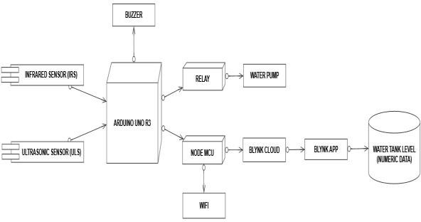

**Figure 2**. System design automatic hand sanitizer container

Figure 2 shows an automatic design. A palm coefficient container system consisting of blocking the infrared sensor block and the ultrasonic sensor. If the infrared sensor feels hand movement, it sends data to Arduino. Arduino sends data to the relay to launch the water pump. If the sensor distance in a clean water container is 35 cm, the sensor sends data to Arduino. Arduino transfers data to MCU nodes as a connection to a BLYNK server. Blynk application is connected to MCU node. Water sends an empty notification to the user.

The circuit scheme can be shown in Figure 3 and Figure 4.

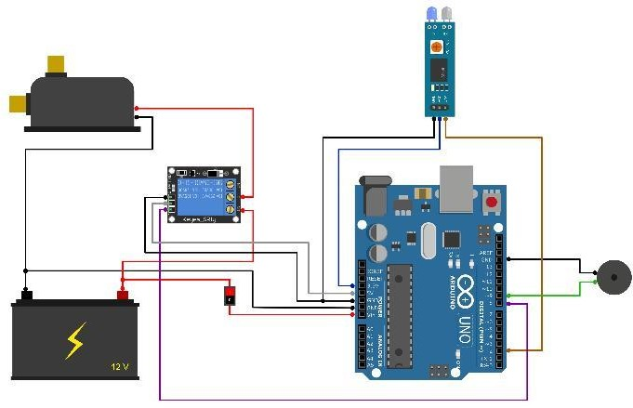

**Figure 3**. Arduino IR sensor and buzzer circuit

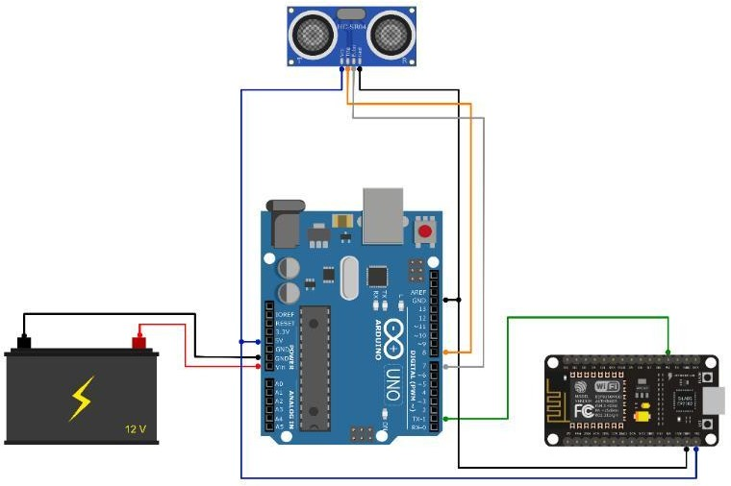

**Figure 4.** Arduino node MCU ultrasonic circuit

The circuit of this research has two systems that can function at the same time. In Figure 3, if infrared (IR) detects the heat and movement of the object, it can operate the spray pump, and so that the cleaner can reach the hand through a small tube, data to the difficult ANU Will be sent.

The sensor connected to Arduino starts operation when the device is activated. The ultrasound of the sensor in this circuit is used to detect the distance to the object. The circuit of FIG. 4 functions when the level of water is less than 10 cm, and the ultrasonic sensor transmits data to the MCU node, and then transmits the data as a WiFi microcontroller to an output device such as a PC or a smartphone. Send data to the MCU node that will be. Case analysis Searra Sear Reference System Design Test Test Design Hardware Design Engineering Engineering Progress,Volume .

# RESULT AND DISCUSSIONS

Figure 5 shows the flow diagram of automotive disinfectants that automatically teaches the water and fills the tank for the process of disinfection of hands.

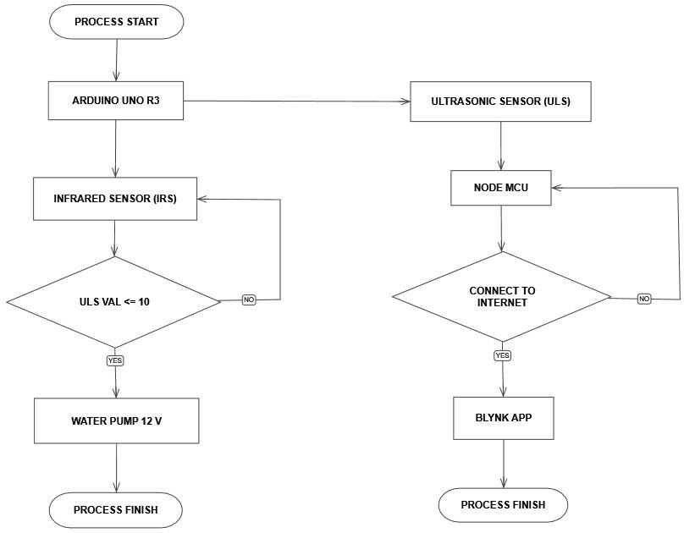

Figure 5. Flow chart automatic hand sanitizer container

The flowchart shows the program loaded into the microcontroller. 1 is a flow diagram of a difficult software design. The ARDuino software processes the acquired input data. The read data and ultrasound of the infrared sensor are sent to the controller to the sensor.

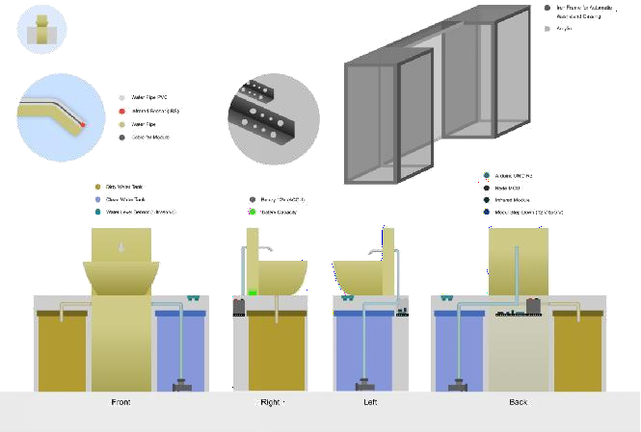

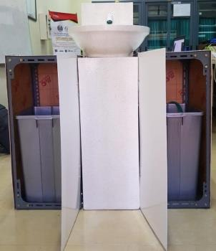

Figure 6. Design automatic hand sanitizer container

Then Arduino sends a value to activate the water pump and node MCU.

This manual disinfectant automatic container is used. The level in the sensor tank to detect temperature, goal movements and water. The automatic water control microcontroller connected to the sensor, as this system uses ultrasonic sensors and infrared sensors. The ultrasonic sensor is detected the ultrasonic data sensor is sent from the sensor to 35 cm from the sensor. Arduino is treated and transferred to MCU nodes as connectivity to BLYNK servers. Thereafter, the BLYNK application can be connected to the MCU node to obtain data sent to the BLYNK server. And this application will send a notification if the cleanwater tank is low. Otherwise, this application does not send a notification because the entry does not receive the signal if the unwarranted water level is less than 10 cm.

In addition, infrared sensors connected to the microcontroller automatically operate the heat and movement of the object. When the input receives a signal, the water automatically passes through the pump. This can prevent bacterial and virus spreading because it does not have to touch the water pump (A) directly. Based on the results of the ultrasonic sensor system, this study has completed seven experiences. The experimental distance is 10 mm to 70 mm.

|  |  |
| --- | --- |
| C:\Users\Paulen\Downloads\WhatsApp Image 2020-09-05 at 14.48.53.jpeg  (a) | C:\Users\Paulen\Downloads\WhatsApp Image 2020-09-05 at 14.48.52.jpeg  (b) |
| P_20200901_131404  (c) | (d) |

**Figure. 7.** (a) Ultrasonic sensor system, (b) Infrared sensor system, (c) Experimental result of infrared sensor for left > 50 mm (d). Experimental result of infrared sensor for right < 50 mm

**Table 1.** Hand Distance Experimental Result Of Infrared Sensor

|  |  |
| --- | --- |
| Distance(mm) | Sensor Information |
| 10 | Sensor Detection |
| 20 | Sensor Detection |
| 30 | Sensor Detection |
| 40 | Sensor Detection |
| 50 | Sensor Detection |
| 60 | Sensor not Detection |
| 70 | Sensor not Detection |

In Table 1, it is configured to operate, set it, an infrared sensor according to the requirements of the distance from the sensitivity of the infrared module. When the tool tries, the object (hand) has a degree of 0 ° 0 °. Infrared sensors are in parallel position.

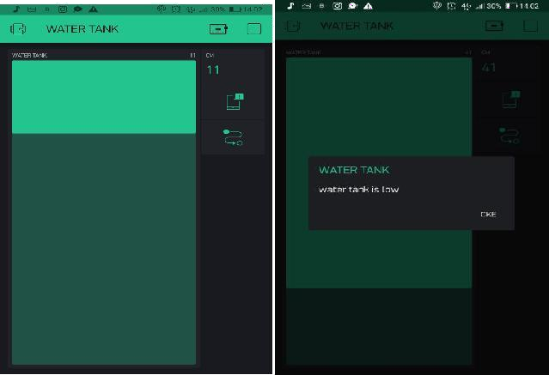

Figure 8. Application design (Blynk app) for monitoring clean water tank

# In this display, the user can monitor the contents of

# the clean water tank. The way this monitoring work is

# by using an ultrasonic sensor to detect the water level

# in the tank. The data from the ultrasonic sensor will be

# processed by a microcontroller in the form of an

# Arduino. Processed by Arduino and transferred to the

# node MCU as connectivity to a Blynk server. Then

# Blynk App can be connected to the node MCU to get

# the data that has been sent to the Blynk server. That

# application gets to send a notification if the clean water

# tank has been low. With information “Water Tank is

# LOW”

# CONCLUSION

Based on the results of testing and discussion, the automatic result of the hand disinfectant can be concluded that it can function without the fact that the transfer data is detected. The infrared light can detect up to 50 mm motion, and the back sensor can detect the water level at a distance of SINOR 35 cm. Ultrasonic sensors can send data to MCU servers and flash to send notifications to users. You can prevent CVIV-19 spreads to conclude that the system can work without problems.

# ACKNOWLEDGMENT

This research was supported by the Department of electrical engineering at Surabaya State University and was conducted in a telecommunications laboratory.

# REFERENCES

1. Ing-K L, Chih-C W, et al February 2020 *Effective Strategies to Prevent Coronavirus Disease-2019 (Covid-19) Outbreak in Hospital* Journal of Hospital Infection
2. World Health Organization 2020 Naming the Coronavirus Disease (COVID-19) and The Virus that Causes it (Internet) Wolrd Health Organization Available on [https://www.who.int/emergencies/diseases/novel](https://www.who.int/emergencies/diseases/novel-coronavirus-2019/technical-guidance/naming-the-coronavirus-disease-(COVID-2019)-and-the-virus-that-causes-it)

[-coronavirus-2019/technical-guidance/naming-](https://www.who.int/emergencies/diseases/novel-coronavirus-2019/technical-guidance/naming-the-coronavirus-disease-(COVID-2019)-and-the-virus-that-causes-it) [the-coronavirus-disease-(COVID-2019)-and-the-](https://www.who.int/emergencies/diseases/novel-coronavirus-2019/technical-guidance/naming-the-coronavirus-disease-(COVID-2019)-and-the-virus-that-causes-it) [virus-that-causes-it.](https://www.who.int/emergencies/diseases/novel-coronavirus-2019/technical-guidance/naming-the-coronavirus-disease-(COVID-2019)-and-the-virus-that-causes-it)

1. Zakir K, Khayal M, Ali A, Hazir R March 2020 Coronavirus Outbreaks: Prevention and Management Recommendations, Drugs & Therapy Perspectives
2. Adityo S, G Martin R, et al March 2020 *Coronavirus Disease 2019: Review of Current Literatures*, Jurnal Penyakit Dalam Indonesia **7.**
3. Yan-R G, Qing-D C, et al 2020 *The Origin, Transmission, and Clinical Therapies on Coronavirus Disease 2019 (Covid-19) Outbreak- An Update on The Status*, Military Medical Research **7.**
4. World Health Organization 2020 *Naming the Coronavirus Disease (COVID-19) and The Virus that Causes it* (Internet) Wolrd Health Organization Available on [https://www.who.int/emergencies/diseases/novel](https://www.who.int/emergencies/diseases/novel-coronavirus-2019/advice-for-public)

[-coronavirus-2019/advice-for-public.](https://www.who.int/emergencies/diseases/novel-coronavirus-2019/advice-for-public)

1. “Construction and Application of an Intelligent Air Quality Monitoring System for Healthcare Environment,” 2014, DOI: 10.1007/s10916-014- 0015-3.
2. T. S. Hong *et al.*, “Systems-Level Quality Improvement A Hand Hygiene Compliance Check System : Brief Communication on a System to Improve Hand Hygiene Compliance in Hospitals and Reduce Infection,” 2015, DOI: 10.1007/s10916-015-0253-z.
3. E. Tartari *et al.*, “Train-the-Trainers in hand hygiene : a standardized approach to guide education in infection prevention and control,”

vol. 4, pp. 1–11, 2019.

1. S. Angelina *et al.*, “Infection Prevention in Practice Assessing the Hawthorne effect on hand hygiene compliance in an intensive care unit,” vol. 2, pp. 10–13, 2020, DOI: 10.1016/j.infpip.2020.100049.
2. D. J. Birnbach, T. C. Thiesen, L. F. Rosen, M. F. Msn, and K. L. Arheart, “Major Article A new approach to infection prevention : A pilot study to evaluate a hand hygiene ambassador program in hospitals and clinics,” *AJIC Am. J. Infect. Control*, vol. 0, pp. 3–5, 2019, DOI: 10.1016/j.ajic.2019.11.007.
3. Aliya H June 2016 *Antibacterial Effectiveness of Commercially Available Hand Sanitizers* International Journal of Biology and

Biotechnology.

1. Sally F B, Allison E A. et. Al 2007 *The Effectiveness of Hand Hygiene Procedures in Reducing The Risks of Interactions in Home and Community Settings Including Handwashing and Alcohol-based Hand Sanitizers* American Journal of Infection Control.
2. Ikegbunam M N, Metuh R C, Anangu L O, Awah N S 2013 *Antimicrobial Activity of Some Cleaning Product Again Selected Bacteria* International Research Journal of Pharmaceutical and Applied Science (IRJPAS).
3. Dawodu O, Juwa O August 2017 *Production of Hand Sanitizers from Cheap Local Materials* Department of Science Laboratory Technology Federal Polytechnic Ede, Osun State Nigeria